CSS 475A Database Systems

Homework 3 (25 possible points) [5% of final grade]

Submit: to Canvas

Due BY: May 13 (Sunday) 11:59 PM
1. (15 points) You need to create a UNIVERSITY database that is used to keep track of students’ transcripts. This is similar but not identical to the database shown in Figure 1.2 in the textbook:

(a) The university keeps track of each student’s name, student number, social security number, current address and phone number, permanent address and phone number, birth date, sex, class (freshman, sophomore, ..., graduate), major department, minor department (if any), and degree program (B.A., B.S., ..., Ph.D.). Some user applications need to refer to the city, state, and zip code of the student's permanent address, and to the student’s last name. Both social security number and student number have unique values for each student.

(b) Each department is described by a name, department code, office number, office phone number, and college. Both name and code have unique values for each department.

(c) Each course has a course name, description, course number, number of semester hours, level, and offering department. The value of the course number is unique for each course.

(d) Each section has an instructor, semester, year, course, and section number. The section number distinguishes different sections of the same course that are taught during the same semester/year; its values are 1, 2, 3, ..., up to the number of sections taught during each semester.

(e) A grade report has a student, section, letter grade, and numeric grade (0, 1, 2, 3,
4 for F, D, C, B, A, respectively).

You will turn in a relational data model as well as SQL scripts containing queries and updates required by your database including creating the database.
Specifics of the relational data model:
- Include the relations
- Include the attributes
- Identify primary key
- Identify any foreign keys where applicable
- Include any other constraints where necessary (can be described in sentences)
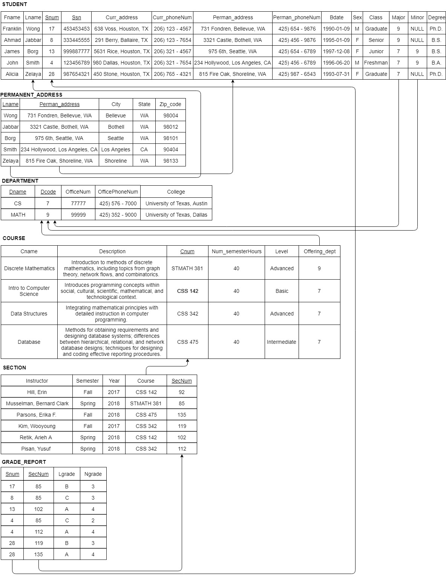
Specifics on SQL scripts:
- Include creating the database (creating tables, specifying attribute data types, domains, specifying constraints)

create table STUDENT
(
Fname VARCHAR(15) NOT NULL,
Lname VARCHAR(15) NOT NULL,
Snum INT NOT NULL,
Ssn CHAR(9) NOT NULL,
Curr_address VARCHAR(50),
Curr_phoneNum VARCHAR(15),
Perman_address VARCHAR(50) NOT NULL,
Perman_phoneNum VARCHAR(15),
Bdate VARCHAR(10),
Sex CHAR(1),
Class VARCHAR(15),
Major VARCHAR(20),
Minor VARCHAR(20),
Degree VARCHAR(20),
primary key(Snum),
unique(Ssn),
constraint STUFK1 foreign key (Major) references DEPARTMENT(Dcode) on update cascade on delete set null
constraint STUFK2 foreign key (Minor) references DEPARTMENT(Dcode) on update cascade on delete set null
);

create table PERMANENT_ADDRESS
(
Lname VARCHAR(15) NOT NULL,
Perman_address VARCHAR(50) NOT NULL,
City VARCHAR(15),
State VARCHAR(15),
Zip_code INT,
constraint PAFK1 foreign key (Lname) references STUDENT(Lname) on update cascade on delete cascade,
constraint PAFK2 foreign key (Perman_address) references STUDENT(Perman_address) on update cascade on delete cascade
);

create table DEPARTMENT
(
Dname VARCHAR(15) NOT NULL,
Dcode INT NOT NULL,
OfficeNum INT,
OfficePhoneNum VARCHAR(15),
College VARCHAR(30),
primary key(Dcode)
unique(Dname)
);

create table COURSE
(
Cname VARCHAR(20) NOT NULL,
Description VARCHAR(100),
Cnum VARCHAR(15) NOT NULL,
Num_semesterHours INT,
Level VARCHAR(10),
Offering_dept INT NOT NULL,
primary key(Cnum),
constraint COUFK foreign key (Offering_dept) references DEPARTMENT(Dcode) on update cascade on delete cascade
);

create table SECTION
(
Instructor VARCHAR(15) NOT NULL,
Semester VARCHAR(10) NOT NULL,
Year INT NOT NULL,
Course VARCHAR(15) NOT NULL,
SecNum INT NOT NULL,
primary key(SecNum),
constraint SECFK foreign key (Course) references COURSE(Cnum) on update cascade on delete cascade
);

create table GRADE_REPORT
(
Snum INT NOT NULL,
SecNum INT NOT NULL,
Lgrade CHAR(1) NOT NULL,
Ngrade CHAR(1) NOT NULL,
constraint GRFK1 foreign key (Snum) references STUDENT(Snum) on update cascade on delete cascade,
constraint GRFK2 foreign key (SecNum) references SECTION(SecNum) on update cascade on delete cascade
);

- Include at least one SELECT, INSERT, UPDATE, and DELETE statements on all tables created

insert into STUDENT values ('Franklin', 'Wong', 17, 453453453, '638 Voss, Houston, TX', '206) 123 - 4567', '731 Fondren, Bellevue, WA', '425) 654 - 9876', '1990-01-09', 'M', 'Graduate', 9, NULL, 'Ph.D.');
select snum, fname, lname from student where snum=17;
update student set curr_phonenum = '425) 765 - 4321' where fname = 'Franklin';
delete from student where snum = 17;

insert into permanent_address values ('Wong', '731 Fondren, Bellevue, WA', 'Bellevue', 'WA', 98004);
select lname, perman_address from permanent_address where city = bellevue;
update permanent_address set city = 'Lynnwood' where zip_code = 98004;
delete from permanent_address where lname = 'Wong';

insert into department values ('CS', 7, 77777, '425) 576 - 7000', 'University of Texas, Austin');
select officenum, officephonenum, college from department where dcode = 7;
update department set officephonenum = '425) 289 - 7000' where dname = 'CS';
delete from department where dcode = 7;

insert into course values ('Data Structures', 'Integrating mathematical principles with detailed instruction in computer programming.', 'CSS 342', 40, 'Advanced', 7);
select cname, description from course where cnum = 'CSS 342';
update course set num_semesterhours = 45 where cname = 'Data Structures';
delete from course where cnum = 'CSS 342';

insert into section values ('Kim, Wooyoung', 'Fall', 2017, 'CSS 342', 119);
select instructor, semester, year, course from section where secnum = 119;
update section set instructor = 'Lee, Wooyoung' where secnum = 119;
delete from section where secnum = 119;

insert into grade_report values (28, 119, 'B', 3);
select snum, lgrade, ngrade from grade_report where secnum = 119;
update grade_report set lgrade = 'A' and ngrade = 4;
delete from grade_report where snum = 28;

- Include at least one SELECT statement provide historical information for a student

select fname, lname, class, major, minor, degree, dcode, college, gr.snum, lgrade, ngrade from student, department, grade_report gr where dcode = 7 and dcode = 9;

- Include at least one SELECT statement providing current registration information for a student

select fname, lname, semester, year, gr.snum from student, section, grade_report gr where semester = 'Spring' and year = 2018;

- Include at least one SELECT statement providing all courses’ information (including the number of sections they each have) for the university

select * from course, section where cnum = course in (select secnum from section where cnum = course);

- Include at least one SELECT statement providing all the students majored in a certain department

select fname, lname, major, minor, dcode from student, department where major = 9 and minor =9;

- Include at least one SELECT statement providing information on how many students a instructor teaches (including all the sections that the instructor is teaching)

select fname, lname, instructor, gr.snum, gr.secnum from student, section s, grade_reprot gr where s.secnum = gr.secnum;

Misc Specifics:
- Include any/all assumptions for your database

Each course should be unique.
Letter grade only has F, D, C, B, and A, and numeric grade only has 0, 1, 2, 3, and
4.
Each student can take several courses at the same semester and year.

2. (10 points) Create the COMPANY database (as shown in Figure 3.6 in the textbook) in SQLite using the COMPANY_database_new_sqlite.txt file on Canvas (see Files/practice). Then specify the following queries on the COMPANY database and show the query results. All the queries must be written as if you only know the database schema but not any actual data stored in the COMPANY database (i.e., for question d, you shouldn’t assume you know that the departments no 1 & 4 have average salary of more than $32,000 and write query like: select … from … where Dno = 1 or Dno = 4)
- Retrieve the names of all employees in department 4 who work less than 20 hours per week on the 'Computerization' project.

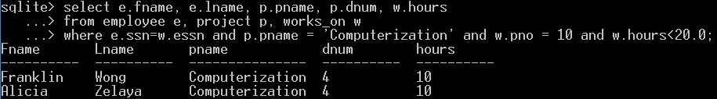

- Retrieve the employee name, salary, and supervisor name for each employee who works in the ‘Research’ department.

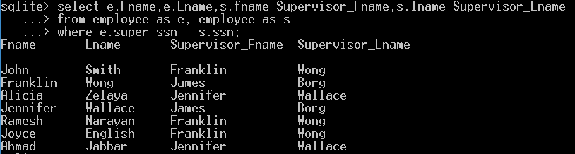

- List the department name and the number of employees in that department who are making more than $32,000.

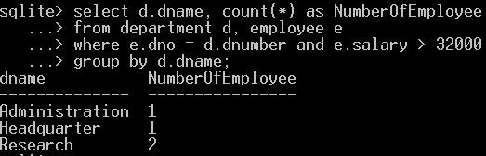

- For each department whose average employee salary is more than $32,000, retrieve the department name and the number of employees in that department.

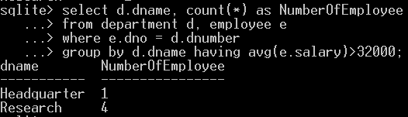

- For each project, retrieve the project name, controlling department name, number of employees, and total hours worked per week on the project.

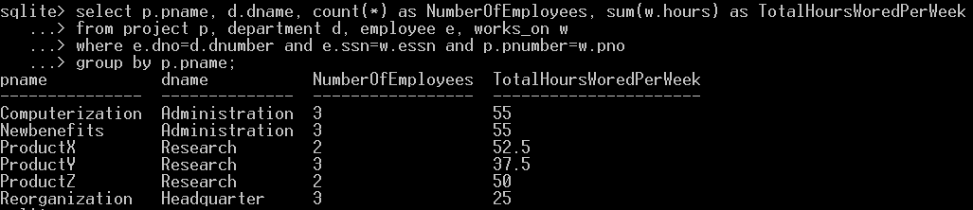

- Use nested query to: Retrieve the names of all employees who work in the department that has the employee with the highest salary among all employees.

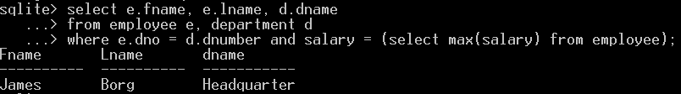

- Use nested query to: Retrieve the names of all employees whose supervisor’s supervisor has '888665555' for Ssn.

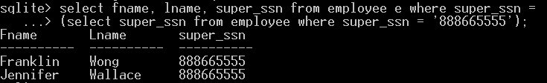

- Use nested query to: Retrieve the names of employees who make at least $10,000 more than the employee who is paid the least in the company.

